6) Total Cost of Purchase (Discounts + Taxes)

import numpy as np

item_prices = np.array([40, 55, 30, 120, 75, 60, 25, 90, 150, 35, 45, 80, 110, 20, 65, 95, 130, 50, 70, 85])
quantities = np.array([2, 1, 3, 1, 2, 2, 4, 1, 1, 3, 2, 1, 1, 5, 2, 1, 1, 2, 2, 1])

discount_rate = 10
tax_rate = 5

total_cost = np.sum(item_prices * quantities)

discount_amount = (discount_rate / 100) * total_cost
cost_after_discount = total_cost - discount_amount
tax_amount = (tax_rate / 100) * cost_after_discount
final_amount = cost_after_discount + tax_amount

print("Total cost:", round(total_cost, 2))
print("Discount amount:", round(discount_amount, 2))
print("Cost after discount:", round(cost_after_discount, 2))
print("Tax amount:", round(tax_amount, 2))
print("Final amount to pay:", round(final_amount, 2))

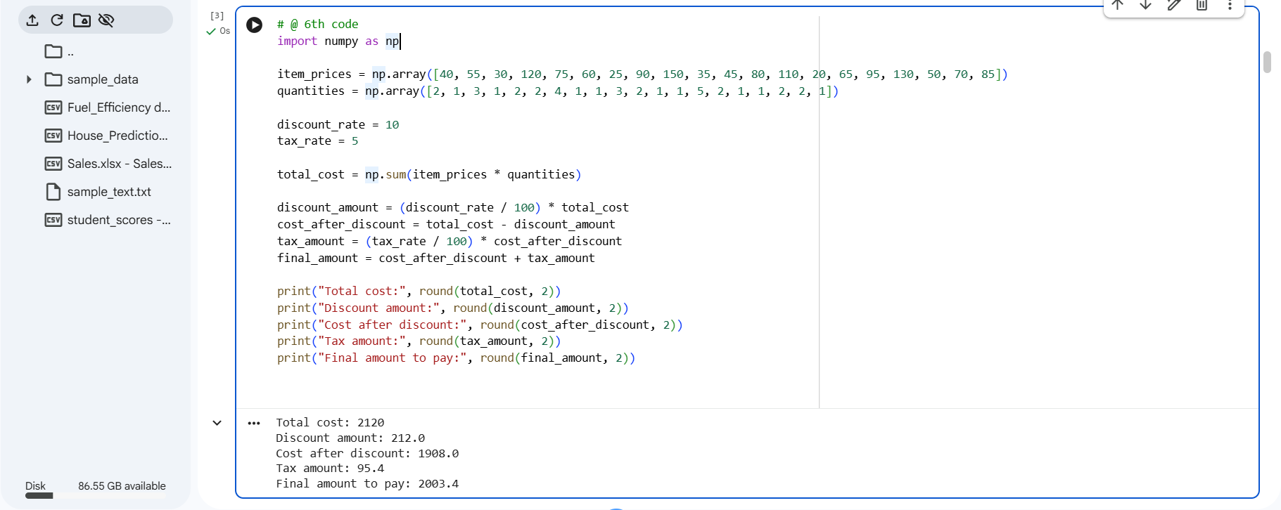
OUTPUT:

7) Customer Orders Analysis
import pandas as pd

order_data = pd.DataFrame({
"Customer_ID": [101,102,101,103,104,102,105,101,103,104,106,107,105,106,108,109,110,108,109,110],
"Order_Date": [
"2023-01-05","2023-01-08","2023-01-12","2023-01-15","2023-01-18",
"2023-02-02","2023-02-05","2023-02-10","2023-02-14","2023-02-18",
"2023-03-01","2023-03-05","2023-03-08","2023-03-12","2023-03-15",
"2023-03-18","2023-03-20","2023-03-22","2023-03-25","2023-03-28"],
"Product_Name": [
"Laptop","Mobile","Laptop","Tablet","Mobile",
"Laptop","Headphones","Tablet","Mobile","Laptop",
"Tablet","Laptop","Mobile","Headphones","Tablet",
"Laptop","Mobile","Headphones","Tablet","Laptop"],
"Order_Quantity": [1,2,1,3,2,1,4,2,1,1,3,2,2,5,1,1,3,2,2,1})

order_data["Order_Date"] = pd.to_datetime(order_data["Order_Date"])

total_orders = order_data.groupby("Customer_ID").size().reset_index(name="Total_Orde")

average_quantity = order_data.groupby("Product_Name")["Order_Quantity"].mean().reset_index()
average_quantity["Order_Quantity"] = average_quantity["Order_Quantity"].round(2)

earliest_date = order_data["Order_Date"].min().date()
latest_date = order_data["Order_Date"].max().date()

print("\n========== E-COMMERCE ORDER ANALYSIS ==========\n")
print("Total Number of Orders by Each Customer:\n")
print(total_orders.to_string(index=False))

print("\nAverage Order Quantity for Each Product:\n")
print(average_quantity.to_string(index=False))

print("\nOrder Date Summary:\n")
print("Earliest Order Date :", earliest_date)
print("Latest Order Date :", latest_date)

print("\n==============================================")

OUTPUT:
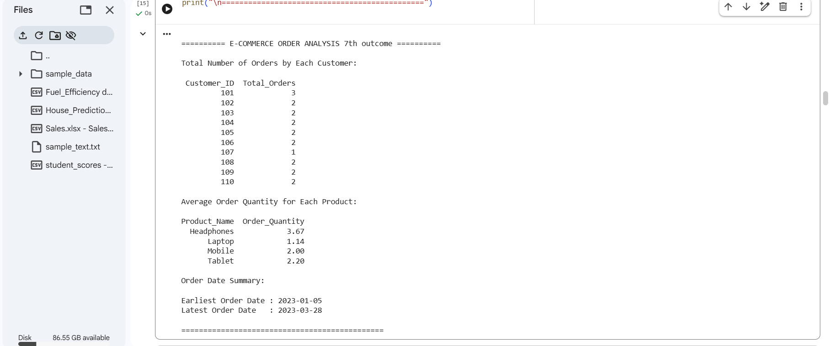
8) Top 5 Products Sold
import pandas as pd
sales_data = pd.DataFrame({
"Order_Date": [
"2023-11-01","2023-11-02","2023-11-03","2023-11-04","2023-11-05",
"2023-11-06","2023-11-07","2023-11-08","2023-11-09","2023-11-10",
"2023-11-11","2023-11-12","2023-11-13","2023-11-14","2023-11-15",
"2023-11-16","2023-11-17","2023-11-18","2023-11-19","2023-11-20"],
"Product_Name": [
"Laptop","Mobile","Tablet","Laptop","Headphones",
"Mobile","Laptop","Tablet","Mobile","Laptop",
"Tablet","Mobile","Laptop","Headphones","Mobile",
"Tablet","Laptop","Mobile","Headphones","Laptop"],
"Quantity_Sold": [2,3,1,2,4,3,1,2,2,3,1,4,2,3,5,2,1,3,2,4]
})
sales_data["Order_Date"] = pd.to_datetime(sales_data["Order_Date"])
past_month_data = sales_data[
(sales_data["Order_Date"].dt.month == 11) &
(sales_data["Order_Date"].dt.year == 2023)]
top_products = (
past_month_data
.groupby("Product_Name")["Quantity_Sold"]
.sum()
.sort_values(ascending=False)
.head(5)
.reset_index(name="Total_Quantity_Sold"))
print(top_products.to_string(index=False))

OUTPUT:
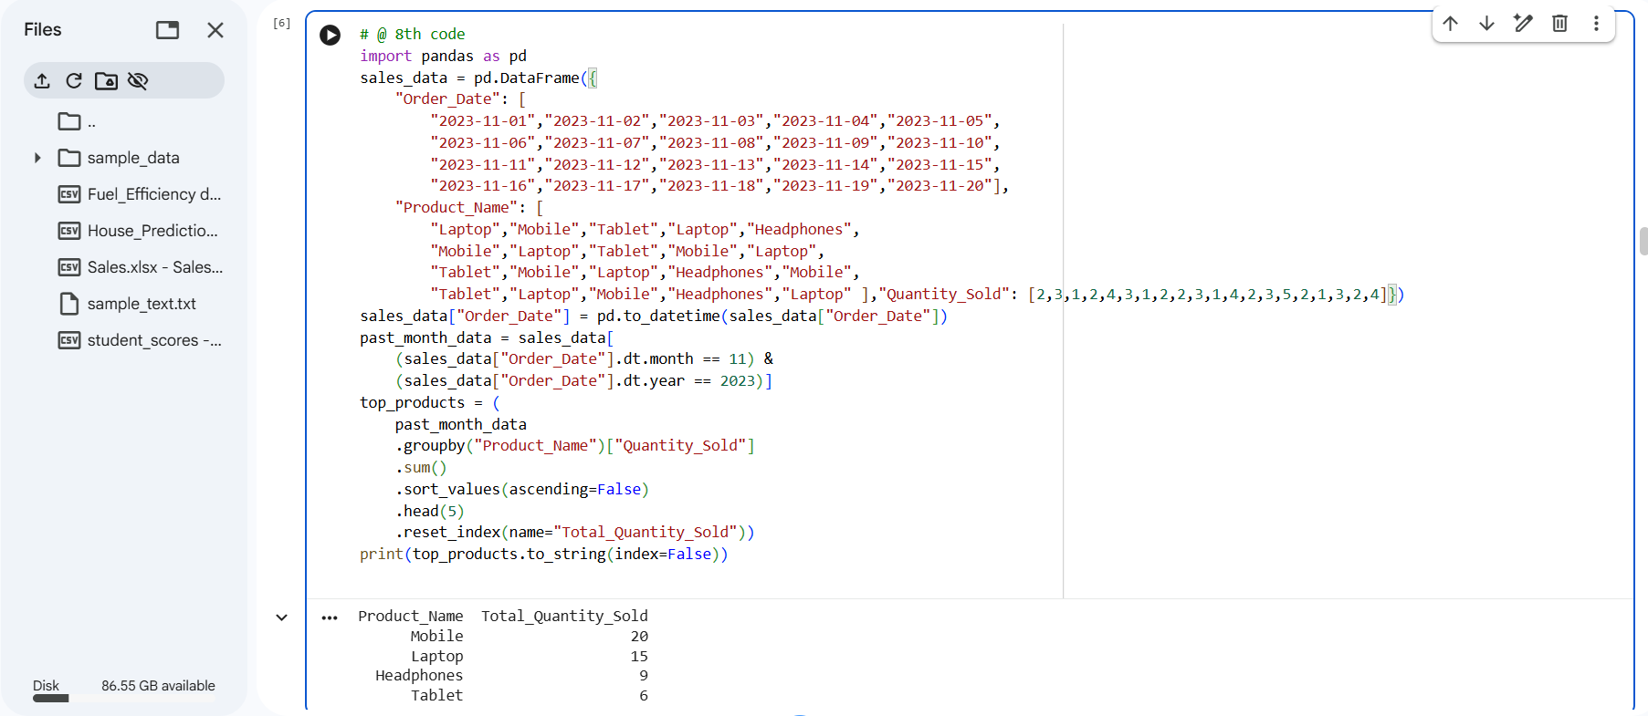

9) Real Estate Analysis
import pandas as pd
property_data = pd.DataFrame({
"Property_ID": [201,202,203,204,205,206,207,208,209,210,211,212,213,214,215,216,217,218,219,220],
"Location": [
"Chennai","Bangalore","Chennai","Hyderabad","Bangalore",
"Chennai","Mumbai","Hyderabad","Mumbai","Bangalore",
"Chennai","Mumbai","Hyderabad","Bangalore","Chennai",
"Mumbai","Hyderabad","Chennai","Bangalore","Mumbai"],
"Bedrooms": [3,4,5,2,4,6,3,5,4,2,3,6,4,5,2,3,4,6,5,4],
"Area_sqft": [
1200,1500,1800,1100,1600,
2200,1400,2000,1700,1300,
1250,2400,1550,2100,1150,
1450,1650,2500,1900,1750 ],
"Listing_Price": [
6500000,8200000,9500000,5600000,7800000,
11000000,9000000,9800000,10200000,7200000,
6700000,11500000,8400000,10000000,6000000,
8900000,8600000,12000000,9700000,9900000]})

average_price_by_location = (
property_data.groupby("Location")["Listing_Price"]
.mean()
.round(2)
.reset_index(name="Average_Listing_Price"))
properties_more_than_4 = property_data[property_data["Bedrooms"] > 4]
count_more_than_4 = pd.DataFrame({
"Properties_with_More_Than_4_Bedrooms": [len(properties_more_than_4)]})

largest_area_property = property_data.loc[
property_data["Area_sqft"].idxmax()
].to_frame().T

print("\nAVERAGE LISTING PRICE BY LOCATION\n")
print(average_price_by_location.to_string(index=False))

print("\nNUMBER OF PROPERTIES WITH MORE THAN 4 BEDROOMS\n")
print(count_more_than_4.to_string(index=False))

print("\nPROPERTY WITH THE LARGEST AREA\n")
print(largest_area_property.to_string(index=False))

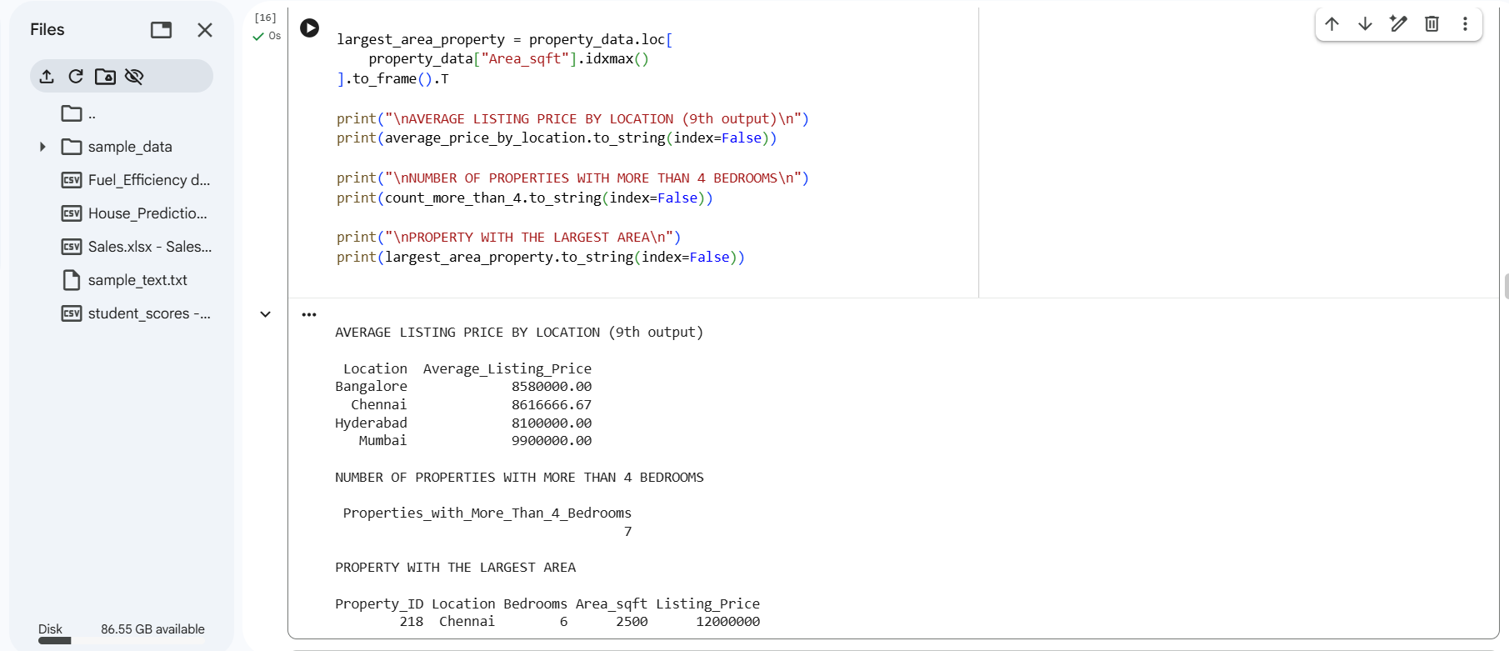
OUTPUT:

10) Monthly Sales Plots
import matplotlib.pyplot as plt
# Sample dataset: Monthly Sales (20 months for variety)months= ["Jan","Feb","Mar","Apr","May","Jun","Jul","Aug","Sep","Oct","Nov","Dec","Jan21","Feb21","Mar21","Apr21","May21","Jun21","Jul21","Aug21"]
sales = [
5000, 6000, 5500, 7000, 6500,
7200, 6800, 7500, 8000, 7800,
8200, 8600, 9000, 9200, 9400,
9700, 9800, 10000, 10200, 10500]
# 1️⃣ Line Plot
plt.figure(figsize=(10,5))
plt.plot(months, sales, marker='o', color='blue', linestyle='-', linewidth=2)
plt.title("Monthly Sales - Line Plot")
plt.xlabel("Month")
plt.ylabel("Sales (₹)")
plt.xticks(rotation=45)
plt.grid(True)
plt.tight_layout()
plt.show()
# 2️⃣ Bar Plot
plt.figure(figsize=(10,5))
plt.bar(months, sales, color='orange')
plt.title("Monthly Sales - Bar Plot")
plt.xlabel("Month")
plt.ylabel("Sales (₹)")
plt.xticks(rotation=45)
plt.tight_layout()
plt.show()

OUTPUT:
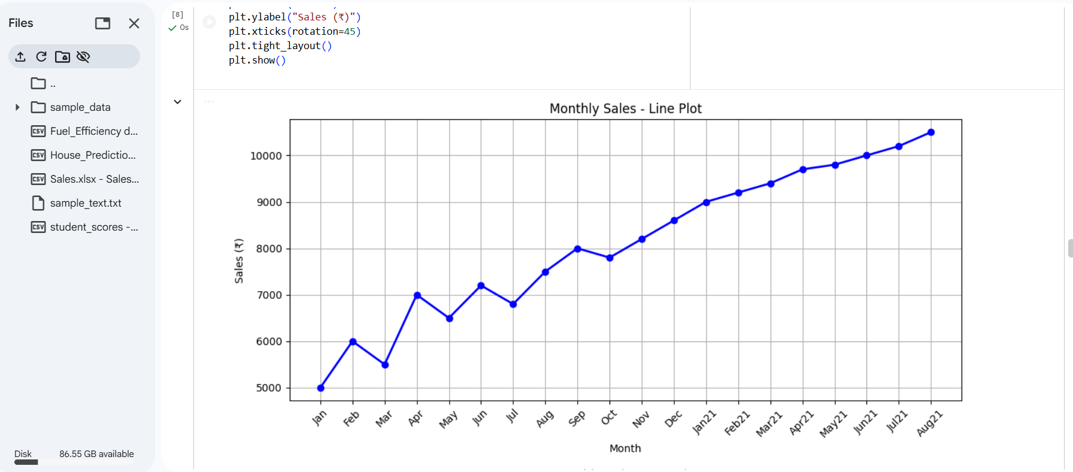

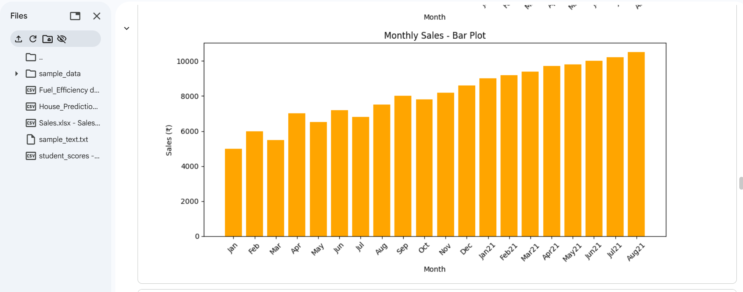

11) Line, Scatter, and Bar Plots of Sales
import matplotlib.pyplot as plt
# Sample dataset: Monthly sales
months = ["Jan","Feb","Mar","Apr","May","Jun","Jul","Aug","Sep","Oct","Nov","Dec"]
sales = [5000, 6000, 5500, 7000, 6500, 7200, 6800, 7500, 8000, 7800, 8200, 8600]
# 1️⃣ Line Plot
plt.figure(figsize=(10,4))
plt.plot(months, sales, marker='o', color='blue', linestyle='-', linewidth=2)
plt.title("Monthly Sales - Line Plot")
plt.xlabel("Month")
plt.ylabel("Sales (₹)")
plt.grid(True)
plt.tight_layout()
plt.show()
# 2️⃣ Scatter Plot
plt.figure(figsize=(10,4))
plt.scatter(months, sales, color='red', s=100) # s= marker size
plt.title("Monthly Sales - Scatter Plot")
plt.xlabel("Month")
plt.ylabel("Sales (₹)")
plt.grid(True)
plt.tight_layout()
plt.show()
# 3️⃣ Bar Plot
plt.figure(figsize=(10,4))
plt.bar(months, sales, color='green')
plt.title("Monthly Sales - Bar Plot")
plt.xlabel("Month")
plt.ylabel("Sales (₹)")
plt.tight_layout()
plt.show()

OUTPUT:
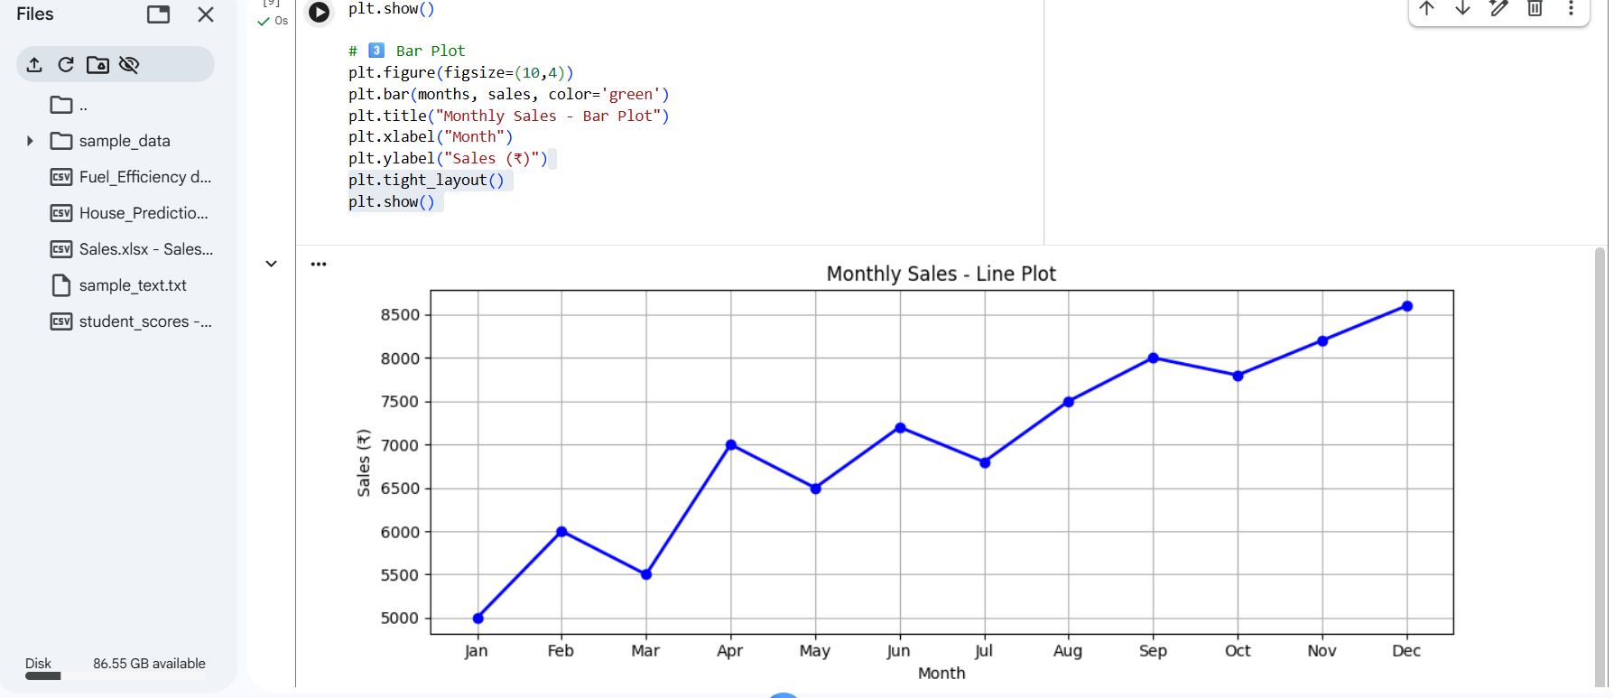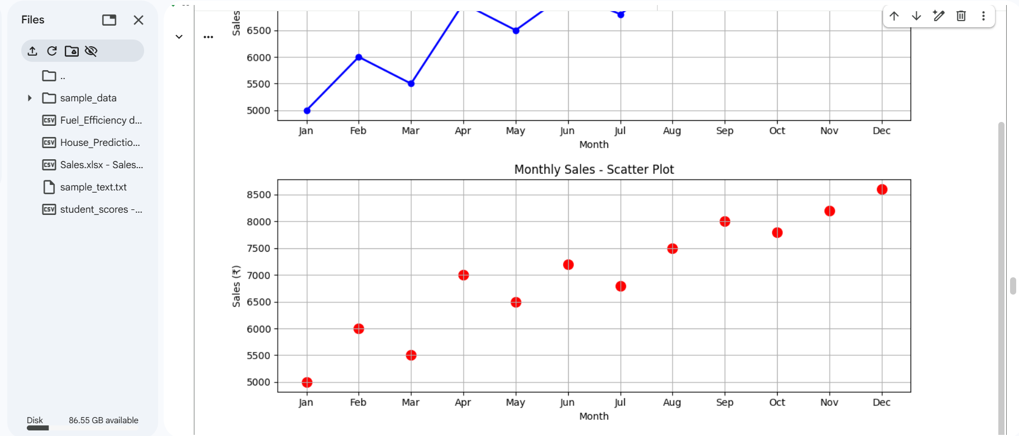
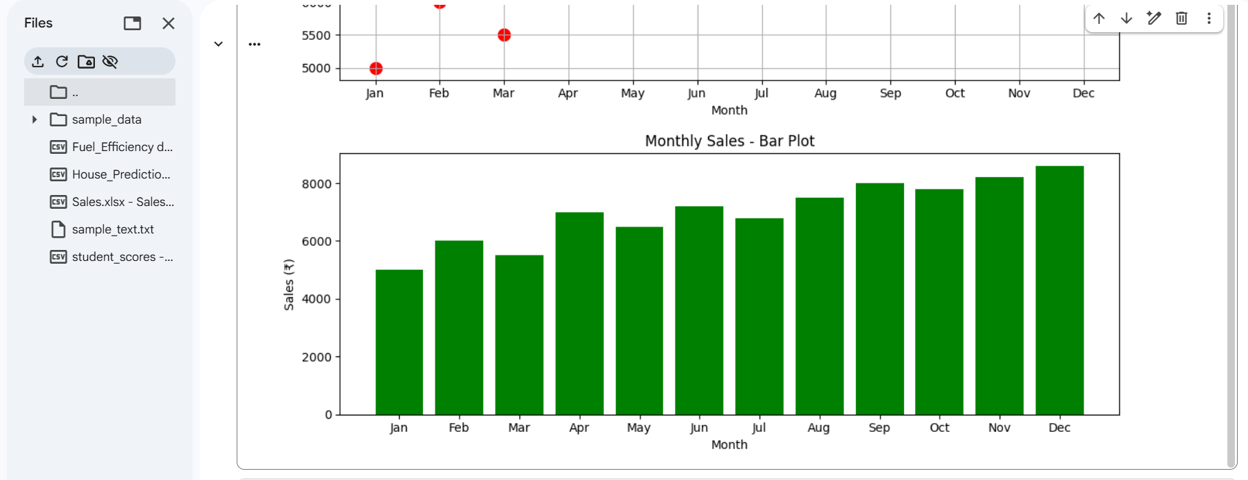

12) Temperature and Rainfall Plots
import matplotlib.pyplot as plt
months = ["Jan","Feb","Mar","Apr","May","Jun","Jul","Aug","Sep","Oct","Nov","Dec"]
temperature = [22, 24, 28, 32, 35, 38, 36, 34, 30, 28, 25, 23] # in °C
rainfall = [80, 60, 70, 50, 40, 20, 10, 15, 30, 60, 75, 90] # in mm
plt.figure(figsize=(10,4))
plt.plot(months, temperature, marker='o', color='orange', linestyle='-', linewidth=2)
plt.title("Monthly Temperature - Line Plot")
plt.xlabel("Month")
plt.ylabel("Temperature (°C)")
plt.grid(True)
plt.tight_layout()
plt.show()
# 2️⃣ Scatter Plot - Rainfall
plt.figure(figsize=(10,4))
plt.scatter(months, rainfall, color='blue', s=100)
plt.title("Monthly Rainfall - Scatter Plot")plt.xlabel("Month")
plt.ylabel("Rainfall (mm)")
plt.grid(True)
plt.tight_layout()
plt.show():
OUTPUT:
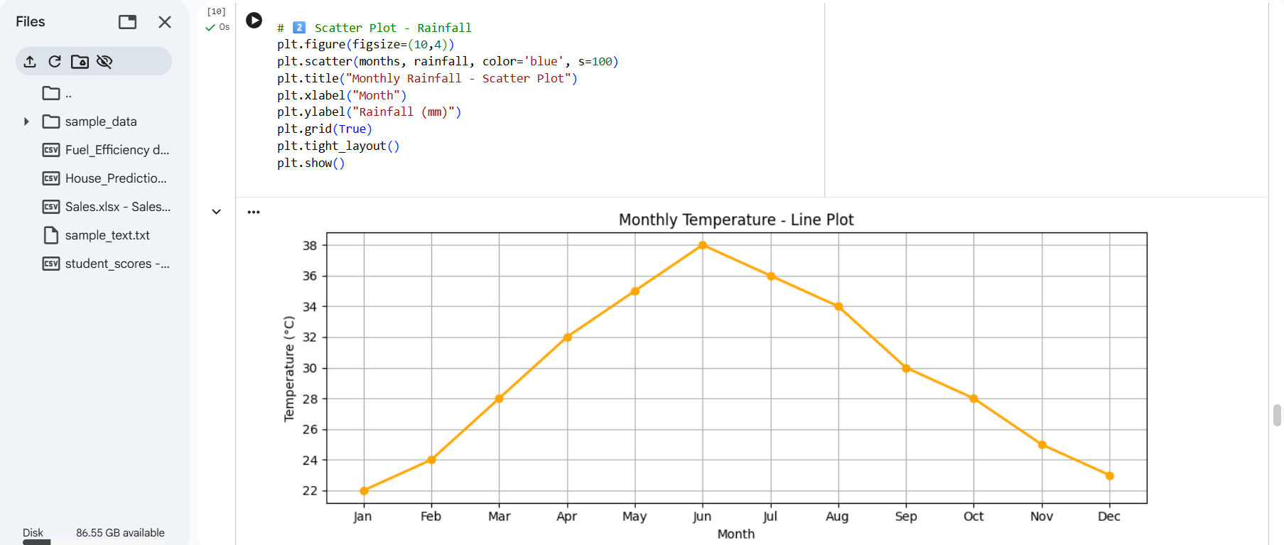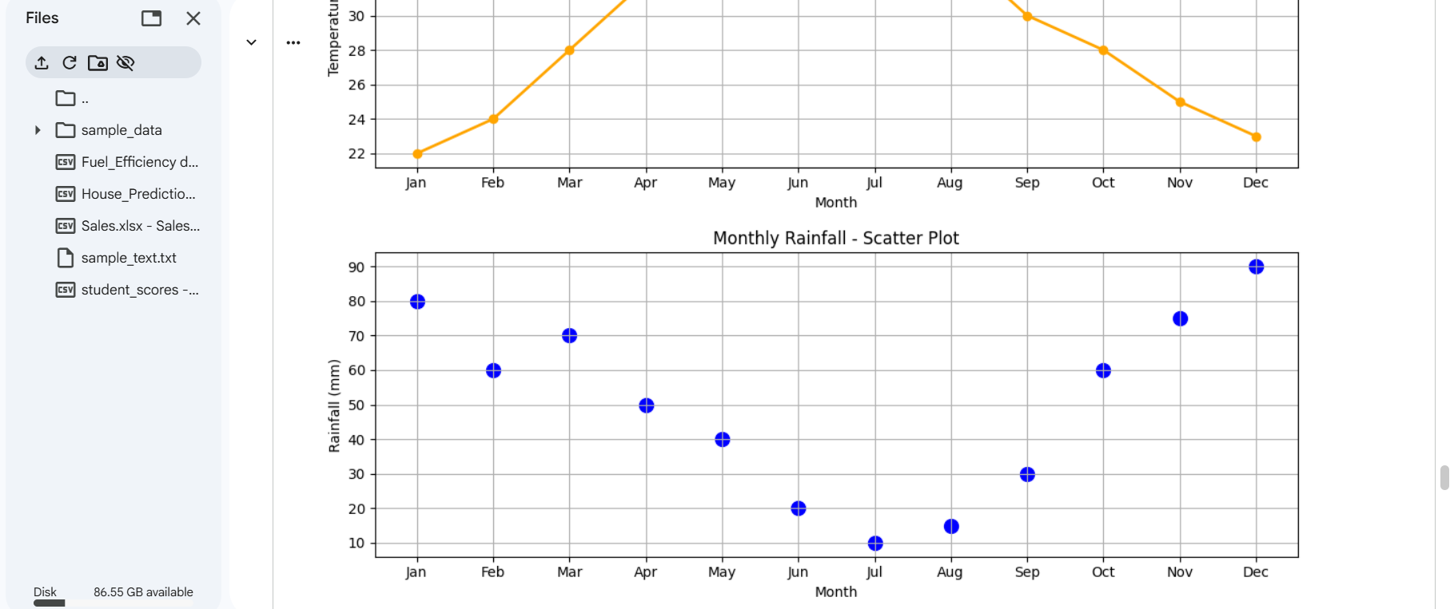

13) Word Frequency in Text File
from collections import Counter
import string

# Step 1: Create sample_text.txt
text = """
Python is a popular programming language. Python is easy to learn and Python is widely used in data science.
Learning Python helps in developing data analysis and data visualization projects. Python programming is fun.
"""

with open("sample_text.txt", "w") as file:
file.write(text)

# Step 2: Read the text file
with open("sample_text.txt", "r") as file:
text = file.read()

# Step 3: Process text
text = text.lower() # convert to lowercase
text = text.translate(str.maketrans("", "", string.punctuation)) # remove punctuation
words = text.split() # split into words

# Step 4: Calculate word frequency
word_freq = Counter(words)
sorted_word_freq = dict(sorted(word_freq.items(), key=lambda x: x[1], reverse=True))

# Step 5: Display frequency distribution
print("{:<15} {:<5}".format("Word","Count"))
print("-"*20)
for word, count in sorted_word_freq.items():
print("{:<15} {:<5}".format(word, count))

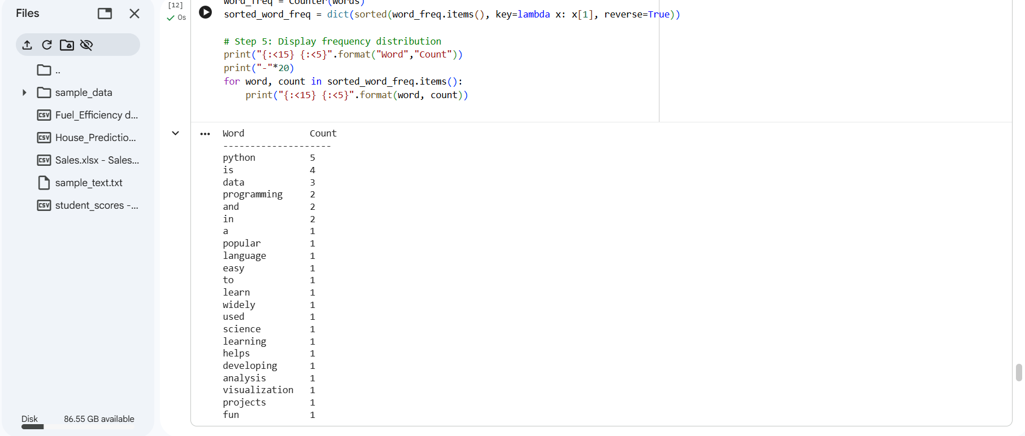
OUTPUT:

14) Frequency Distribution of Customer Ages

import pandas as pd
from collections import Counter
sales_data = pd.DataFrame({
"Customer_ID": [101,102,103,104,105,106,107,108,109,110,
111,112,113,114,115,116,117,118,119,120],
"Customer_Age": [25,30,22,30,28,25,40,35,22,30,
28,25,40,35,22,30,28,25,40,35],
"Product_Name": ["Laptop","Mobile","Tablet","Laptop","Headphones",
"Mobile","Laptop","Tablet","Mobile","Laptop",
"Tablet","Mobile","Laptop","Headphones","Mobile",
"Tablet","Laptop","Mobile","Headphones","Laptop"],
"Quantity_Sold": [1,2,1,3,2,1,4,2,1,1,3,2,2,5,1,1,3,2,2,1]})
ages = sales_data["Customer_Age"].tolist()
age_freq = Counter(ages)
sorted_age_freq = dict(sorted(age_freq.items()))
print("{:<10} {:<5}".format("Age","Count"))
print("-"*15)
for age, count in sorted_age_freq.items():
print("{:<10} {:<5}".format(age, count))

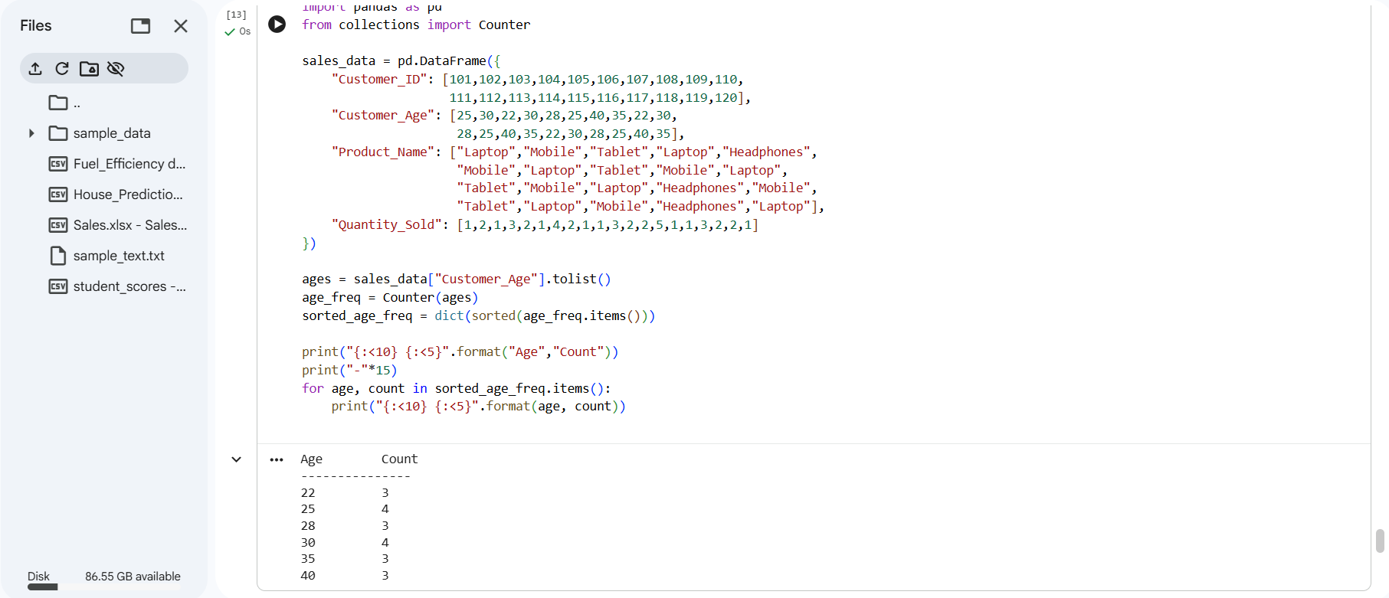
OUTPUT:

15) Frequency Distribution of Likes
import pandas as pd
from collections import Counter
post_data = pd.DataFrame({
"Post_ID": [201,202,203,204,205,206,207,208,209,210,
211,212,213,214,215,216,217,218,219,220],
"Likes":[5,10,5,15,20,5,10,15,5,10,20,5,15,10,5,10,15,20,5]})
likes = post_data["Likes"].tolist()
likes_freq = Counter(likes)
sorted_likes_freq = dict(sorted(likes_freq.items()))
print("{:<10} {:<5}".format("Likes","Count"))
print("-"*15)
for like, count in sorted_likes_freq.items():
print("{:<10} {:<5}".format(like, count))
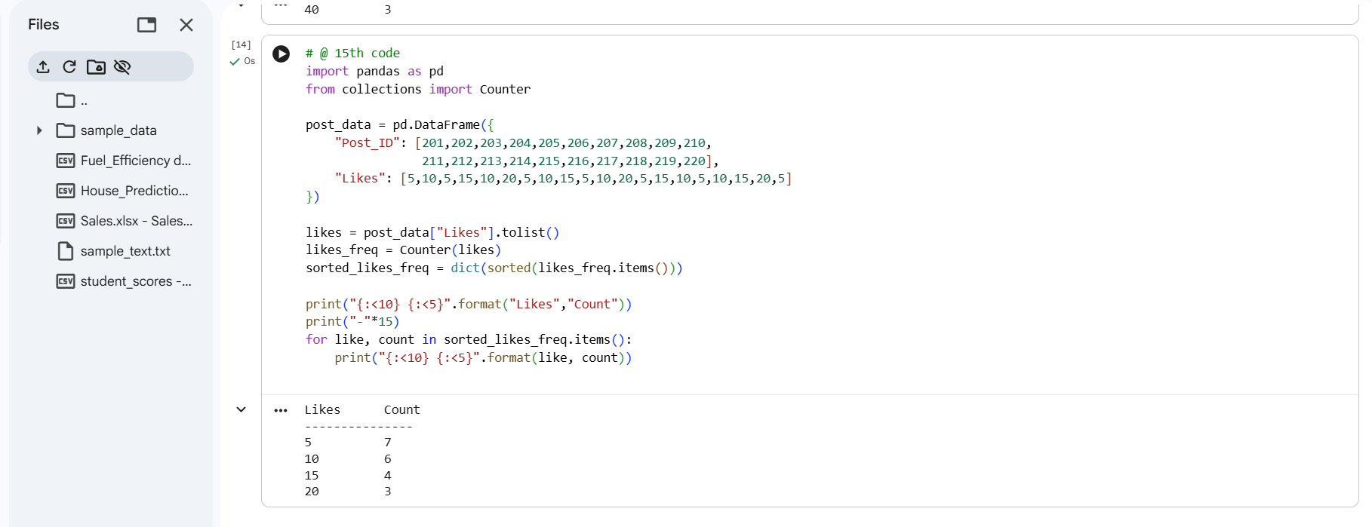
OUTPUT:

